Experiment 3

Capacitance

A bridge circuit is used to determine the capacitance of a parallel plate capacitor. Once the capacitance is found, the dielectric constant of the material separating the plates is subsequently determined.

Theory

Bridge circuits are designed to allow the determination of the value of an unknown circuit element such as a resistor, capacitor, or an inductor. The circuit diagram for a typical bridge is shown in Figure 1.

The bridge elements are connected between junctions AC, BC, AD, and BD. V represents either an AC or DC voltage source and G represents a null detecting device such as a galvanometer, a voltmeter, or an oscilloscope.

Generally, one or more of the circuit elements in the bridge can be varied until the potential difference between junctions A and B (V _{AB}) is zero. When this situation exists, the bridge is said to be balanced or is "nulled." The following relationships then hold for the voltages in the main branches:

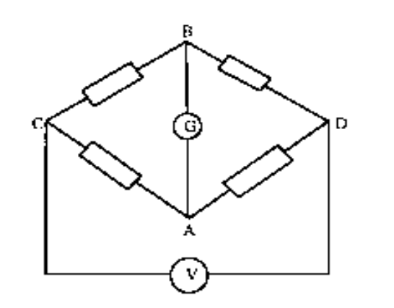

Figure 1. A typical bridge circuit.

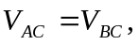 (1)
and
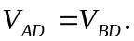 (2)

When (1) is divided by (2) and rearranged, the voltage across any branch can be found in terms
of the remaining three. For example, the voltage between junctions A and D is

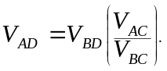 (3)

The bridge for this experiment is shown in Figure 2. The capacitor whose capacitance is to be determined is connected between junctions A and D with a known capacitance between B

and D. A potentiometer is connected from A to C to B and is capable of being adjusted so as to vary the voltages V_{AC} and V_{BC}. The null detector is an oscilloscope connected to the circuit through a transformer whose function it is to isolate the oscilloscope from the bridge circuit so that no two separate points in the circuit are at ground potential.
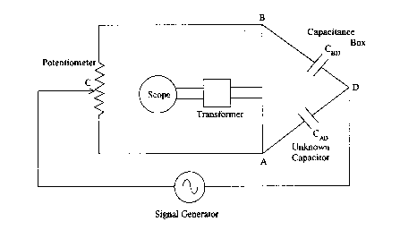

Figure 2. The capacitance bridge.

When the bridge is nulled, (3) holds and a current I, flows from C to A to D and a current I₂ flows from C to B to D. The voltages across the branches from A to C and from B to C
are

 and 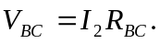 (4)

As will be seen when AC theory is discussed, the voltage across a capacitor with capacitance C, current I, and frequency is

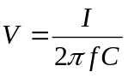

The voltages across branches AD and BD are

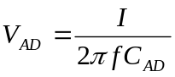 and 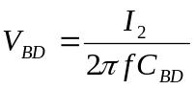 (5)

When (4) and (5) are substituted into (3), the result is

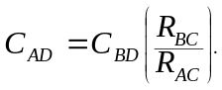 (6)

Therefore, the unknown capacitance C _{AD} can be determined. C _{BD} is a known capacitance, and R _{AC} and R _{BC} are the resistances of the potentiometer from terminal A to C and from B to C, respectively. (Refer to Figure 3.)
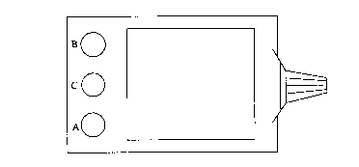
Figure 3. The potentiometer, showing the terminals corresponding to the respective junctions in the bridge circuit.

The potentiometer is calibrated so that R _{AC} corresponds to the reading R on the face of the potentiometer and R _{BC} is (10 - R). Equation (6) then becomes

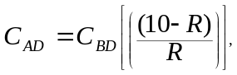 (7)

which is the working equation for the capacitance bridge. The bridge, therefore, can be used to determine the value of capacitance for any capacitor.

In this experiment, C _{AD} represents the capacitance of a parallel plate capacitor whose value, in terms of its physical properties, is

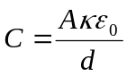 (8)

where A is the area of one of the plates, d is the distance between the plates (or the thickness of the dielectric), __ is the dielectric constant, and co is the permittivity of free space. The dielectric constant of the material between the plates of the unknown capacitor can now be found by using the equation for a parallel plate capacitor (8) where the plates are circular. If the plates have a diameter D, then the capacitance can be expressed as

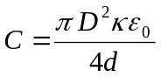 (9)

and the dielectric constant is

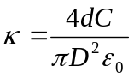, (10)

where the value of capacitance, C, is found using (7).

Another way to determine the dielectric constant is to find the capacitance of the capacitor with the dielectric in place between the circular plates, C_{d}, and then find the capacitance without the dielectric in place, C_{o}. The ratio of the two capacitances equals the dielectric constant,

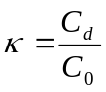. (11)

Apparatus

o oscilloscope with leads o 2 circular aluminum plates
o signal generator o I pressed mica sheet
o transformer o I glass plate
o potentiometer, ±3% o ruler
o 8 leads o micrometer
o capacitance box, ±5% from 0.0001 μF to 0.00047 μF
±10% from 0.001 μF to 0.22 μF

Procedure

- Measure the diameter of one aluminum plate with the ruler. Use the micrometer and measure the thickness of the pressed mica sheet and the glass plate.

- Insert the pressed mica sheet between the aluminum plates, place the plates on the table with the connection points overhanging the edge of the table, and cover the plates with a book.

- Connect the bridge circuit as shown in Figure 2. (Whenever possible used banana plugs instead of alligator clips. The electrical contact is better and the banana plugs do not damage the plastic terminals.)

- Turn on the oscilloscope and the signal generator, and set the frequency of the sinusoidal signal on the generator to 1000 Hz. Set the potentiometer to a reading of 5.00. Adjust the oscilloscope until approximately 5 cycles are seen on the CRT.

- First adjust the dial on the capacitance box until the minimum sinusoidal signal is seen. On the CRT. Now adjust the potentiometer until a minimum signal is obtained on the CRT. Record both the capacitance box reading, CIID, and the potentiometer reading, R.
- Replace the pressed mica sheet with the glass plate and repeat steps (1) through (5).

Analysis

Use (7) to calculate the capacitance of the unknown capacitor when the pressed mica sheet is inserted between the aluminum plates. Repeat this calculation for the glass plates. Equation (10) can now be used to determine the dielectric constant of pressed mica and glass. In a results table report the experimental values of the dielectric constant you found, the theoretical values, and the percentage error (if appropriate).

Conclusions

Explain what factor(s) caused the greatest errors in your determination of the dielectric constant and why.

